DIS-US-CUL-Mississippian-Shell Gorget

1 3/4" SHELL SERPENT GORGET-EX BURKE-TUKABACHEE SITE, ALABAMA.

MEASURES 2 1/8 INCHES WIDE AND 1 1/2 INCHES HIGH.

FROM THE COLLECTION OF DR. R.P. BURKE OF ELMORE COUNTY, ALABAMA.

FOUND AT TUKABACHEE SITE, ALABAMA.

**Tukabatchee** or **Tuckabutche**) ([Creek](https://en.wikipedia.org/wiki/Muscogee_language): *Tokepahce* [[1]](https://en.wikipedia.org/wiki/Tukabatchee" \l "cite_note-1)) is one of the four mother towns of the [Muscogee Creek confederacy](https://en.wikipedia.org/wiki/Muscogee_Creek_confederacy)[[2]](https://en.wikipedia.org/wiki/Tukabatchee" \l "cite_note-2) The pre-removal tribal town was located on the [Tallapoosa River](https://en.wikipedia.org/wiki/Tallapoosa_River) in the present-day state of [Alabama](https://en.wikipedia.org/wiki/Alabama).

The town is believed to be the first site of the ancient busk fire which began the [Green Corn Ceremony](https://en.wikipedia.org/wiki/Green_Corn_Ceremony). Tukabatchee was the home of [Big Warrior](https://en.wikipedia.org/wiki/Big_Warrior), one of the two principal chiefs of the Creeks until his death in 1826. Chief [Opothleyahola](https://en.wikipedia.org/wiki/Opothleyahola) was born here in 1780.[[3]](https://en.wikipedia.org/wiki/Tukabatchee" \l "cite_note-EOHC-Opothleyahola-3)

In 1811 [Tecumseh](https://en.wikipedia.org/wiki/Tecumseh) and [Tenskwatawa](https://en.wikipedia.org/wiki/Tenskwatawa) (better known as the Prophet) addressed Creek leaders in the Tukabatchee town square. Tecumseh was so disappointed in Big Warrior's response at the end of his speech against American expansion that he said upon reaching Chalagawtha the Prophet would "...stamp his foot and all of Tuckabatchee's cabins would fall." The town was leveled by the New Madrid Earthquake a month later.[[*citation needed*](https://en.wikipedia.org/wiki/Wikipedia:Citation_needed)]

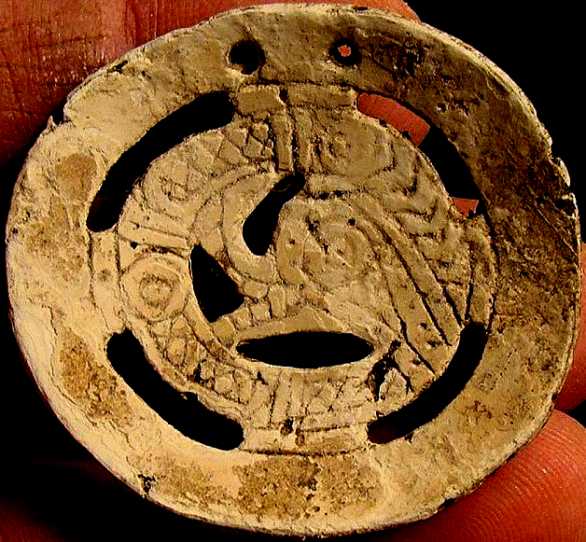 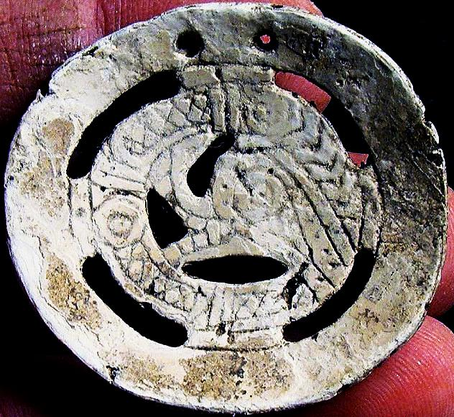

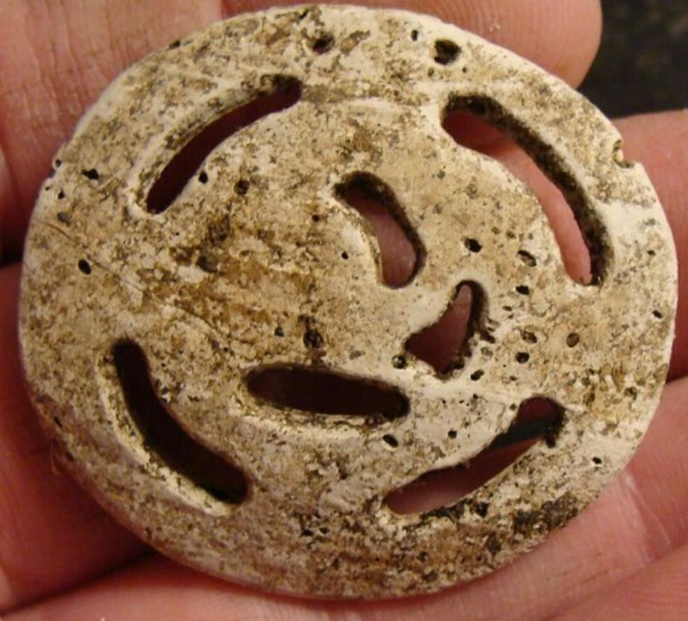

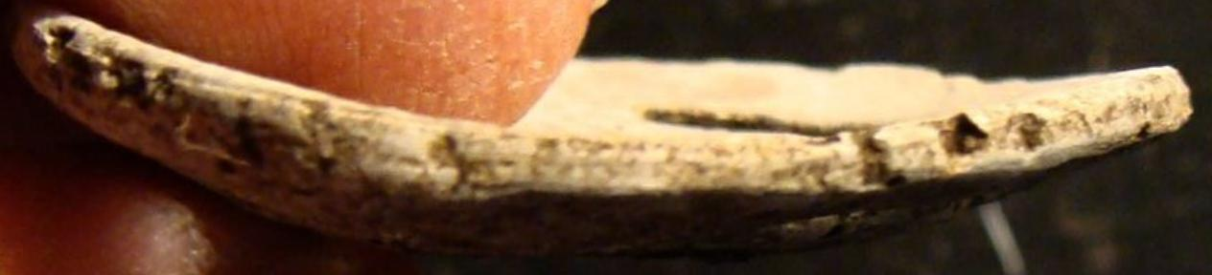

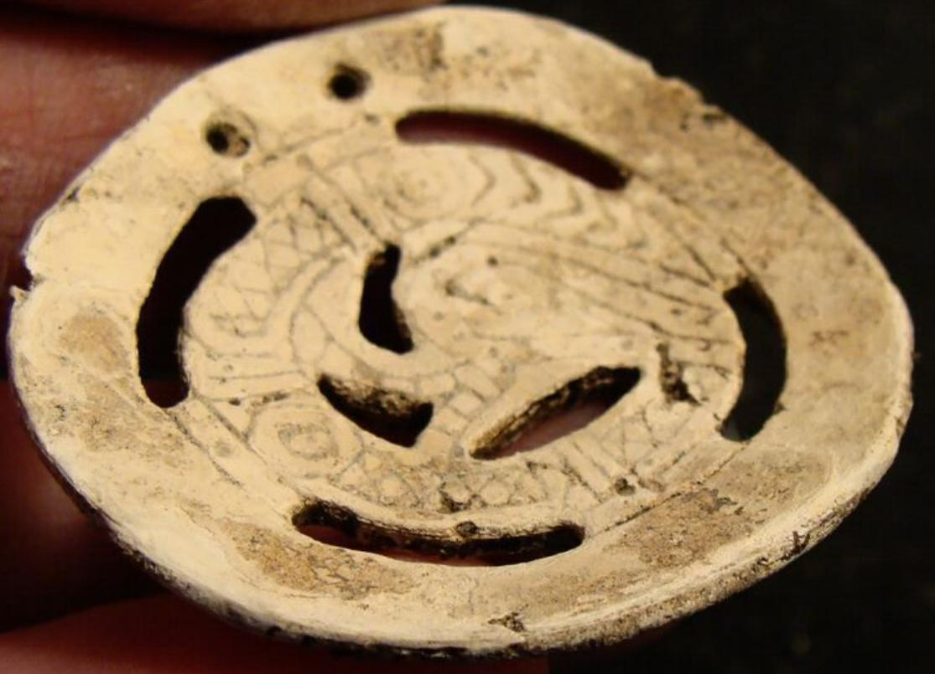

Sold by [plantations](http://myworld.ebay.com/plantations) ( [16977](http://feedback.ebay.com/ws/eBayISAPI.dll?ViewFeedback&userid=plantations) )

### Delivery package 1 of 1

Estimated delivery Thursday, Oct 8, 2015 - Monday, Oct 12, 2015

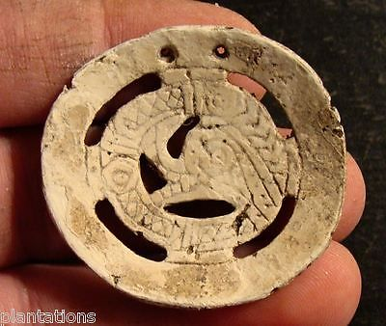

#### [1 3/4" INDIAN SHELL SERPENT GORGET-EX BURKE-TUKABACHEE SITE, ALABAMA](http://www.ebay.com/itm/291548524031)

|  |  |
| --- | --- |
| Item price | $800.00 |
| Quantity | 1 |
| Item number | 291548524031 |
| Shipping service | USPS Priority Mail |

## Shipping address

Ralph J Coffman Jr

149 Atlantic Ave

Swampscott MA 01907-2427

United States

## Order total

|  |  |
| --- | --- |
| Subtotal | $800.00 |
| Shipping | Free |

**Total**

$800.00